**The appendix**

Figure1 The amount of Arts for different years

*Note.* It shows the general number of arts in different years.

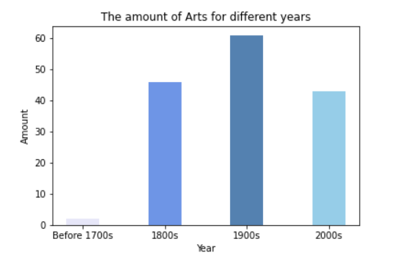

Figure2 Year of art distribution

*Note.* It shows the ratio of the number of artworks appearing in different years

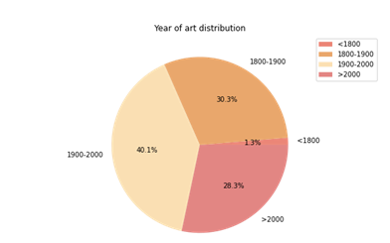

Figure3 Public art heatmap

*Note.* The heatmap shows the space distribution with colors

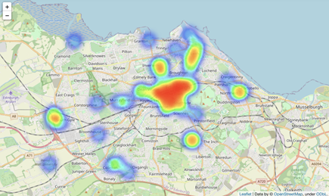

Figure 4 Art position

*Note*. It shows the general positions information of arts in different centuries.

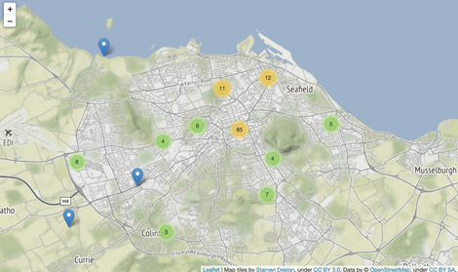

Figure 5 Wordcloud for public arts type

*Note.* Wordcloud for public arts type shows the most frequent use public arts type in Edinburgh.

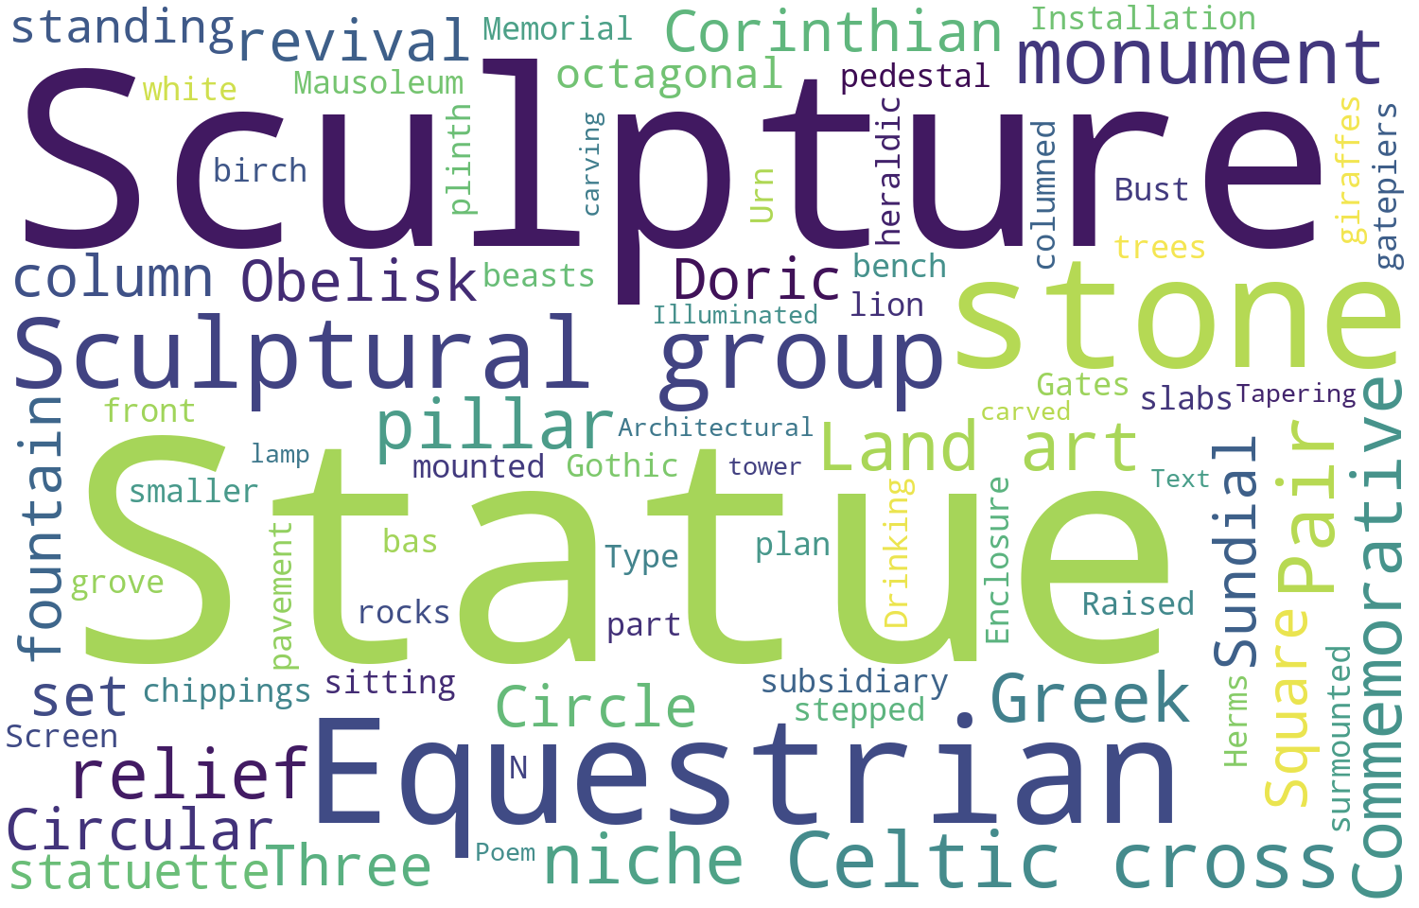

Figure 6 Location scatterplot

*Note*. It shows different public arts in Edinburgh’s space distribution.

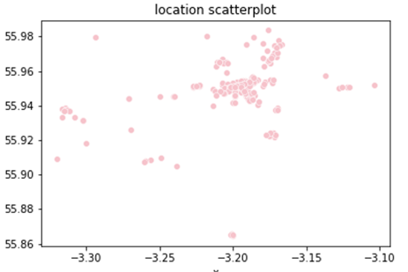

Figure 7 The appearance date distribution

*Note*. The appearance date distribution shows the year distribution for arts.

